SAE Project

- Choose a Supervised Agricultural Experience and approve your idea with your instructor
  - MUST relate to agriculture
  - MUST challenge you in some way (physically, mentally) (improve a skill, learn new skill, teach someone else, perform a task more efficiently, etc.).
    - For example you can NOT cut lawn, you could start your own lawn care business, research and try 10+ lawn design patterns, learn to maintain your mower, etc.)
  - MUST be able to sustain TWENTY hours of work per term of agricultural education MINIMUM
    - Some students will finish 20 hours in a week; others will be challenged to complete 20 hours. Find something that is realistic for you and your abilities
  - Determine if your project is placement (paid or unpaid), entrepreneurship, research or exploratory.
- APPROVE SAE with instructor and set goals for yourself in your notebook in SAE section.
  - MUST be SMART (Specific, Measurable, Attainable, Realistic, Timely)
  - Discuss goals with instructor and get signed off then RECORD on hard copy instructor sheet.
- LOG IN to www.theaet.com to add your experience
  - Hit STUDENT on the right hand side to login. Your Chapter is WI0159. Your username is your Mishicot user name (ex:19grlu) and your password to start is mishicot (you can change this once you login but make sure you retain or write it down for future reference.
  - Once you login you will see your Dashboard, which should look like the photo below. Confirm that your name appears on the upper left.

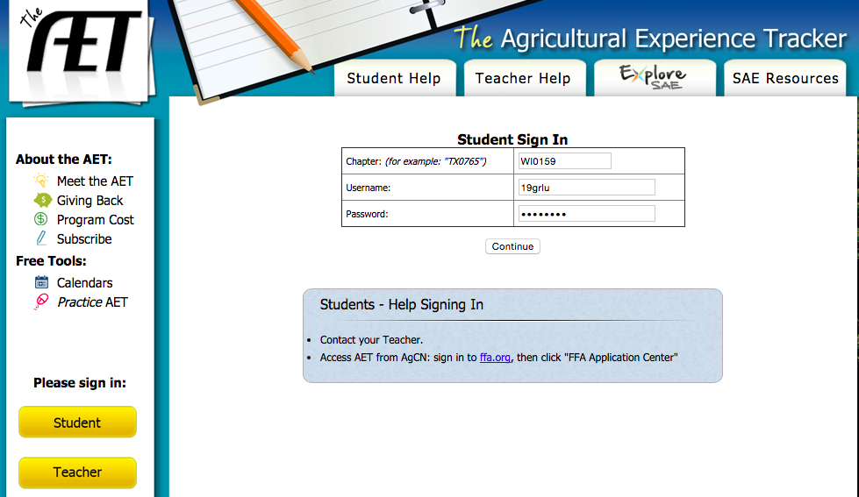
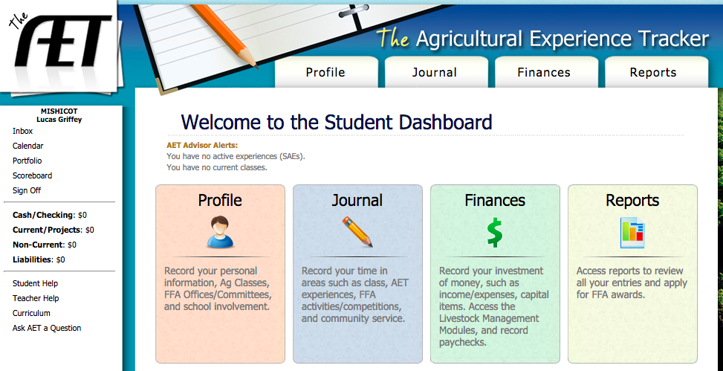

  - Use the PROFILE section to add your agriculture class you are currently in. This is also where you can change your password.
    - If you are a FFA member who will be applying for scholarships or awards you will also need to build a resume in this section. You can copy and paste from WisCareers or type directly into AET.

  - Use the JOURNAL section to add your SAE.
    - Go to EXPEREINCE MANAGER (SAE) and click ADD NEW on the top of the page. Add the name and description of your SAE. This is your first assignment. Ask peers and Mrs. Propson if you are unsure what type of SAE you have. If you are successful your page should look similar to the photo below.

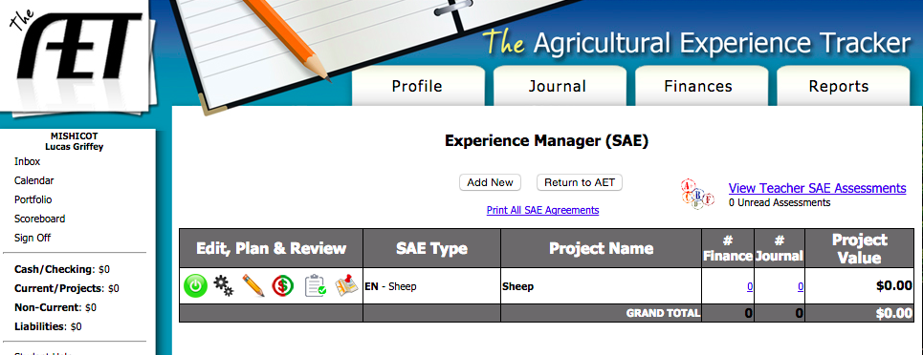

  - LOG your hours by clicking “TIME IN YOUR AET EXPERIENCES” on the JOURNAL dashboard.
    - Classroom – You need a minimum of FOUR journal entries from FOUR different days DURING THE TERM that add to a MINIMUM of TWENTY hours, PER TERM.
(See Mrs. Propson if you will have difficultly completing this). See example log below.
    - FFA Members – It is in your best interest to be most competitive in your SAE area, scholarships and degrees to log ALL experiences throughout your FFA career.
      - For example –all hours showing and preparing sheep for fair over the summer as well as all hours working on a charter fishing boat over the summer and all hours assisting put on educational presentations at the elementary about agriculture during the school year.
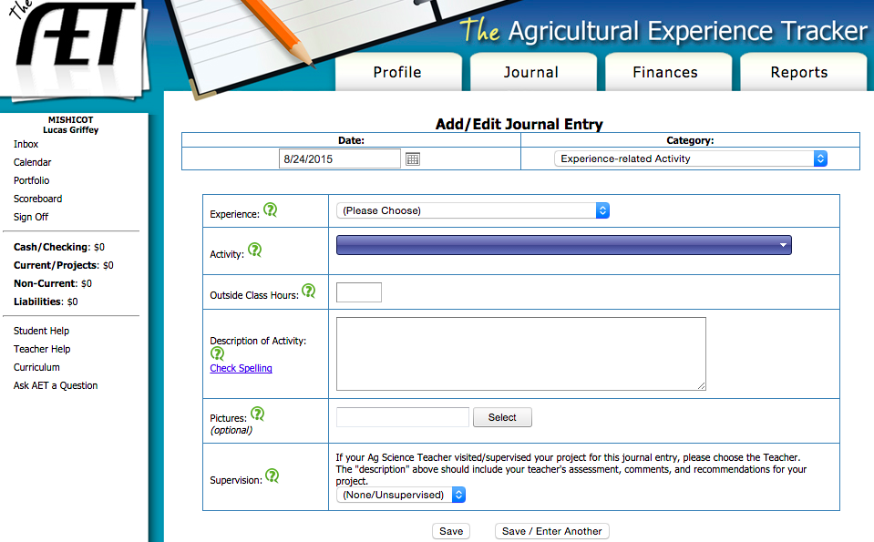

During the course of the class we will have SAE check in points that will be unannounced as well as announced. Make sure that you are working on your SAE throughout the class and can explain what you are doing, learning, and showcase your records on AET.

  - Final Project
    - SAE PRESENTATION – Create a 3-5 minute presentation about your SAE that includes the following:
      - ONE to SIX photos of YOU in/doing your SAE. You MUST be in the photo, action shots preferred.
      - Recap of what your SAE was, goals you had, progress you made.
      - Discussion of how this SAE will impact your future, career, college readiness, taught you lessons or formed networks, etc. (real life application)
      - Proper public speaking and professionalism throughout the presentation
      - Examples, videos, samples or other ways to both engage your audience and meet your four to six minute timeframe.

    - SAE REFLECTION – (We will do this together in class)
      - Go to REPORTS page on far right of screen.
      - Click “Degree and Application Manager”
      - Add new “Proficiency Application”
      - Click Blue “APPLICATION” link to open.
      - Set up using COVER on left toolbar.
        - You MUST complete the following reflections (using left tool bar to navigate)
          - Cover
          - Proficiency Area
          - Basic Set Up
          - PERFORMANCE REIVEW A, B, C
            - Be detailed and use evidence (no fluff)
            - Recap your goals (if ongoing SAE ex: started freshmen year discuss long term goal success)
          - MINIMUM 1 PHOTO, Maximum of 6 WITH CAPTION(s)
            - YOU must be in the photo should be an “action shot” if possible.
    - SAE AUDIENCE GUIDE – As you watch other peers SAE presentations you will be completing a one page double-sided reflection analyzing their presentations and commenting on their experiences.

- GRADING – Your SAE is worth 10% of your grade, enough to drop or raise you one full letter grade. It is a 100-point project. See breakdown below:
  - 5 points – SAE Approval with your instructor
  - 20 points – SAE Check-In’s
  - 20 points – SAE Journals
  - 30 points – SAE Presentation
  - 30 points – SAE Reflection
  - 5 points – Audience Guide

- RESOURCES
  - www.mishicotffa.org, www.ffa.org, www.theaet.com
  - Community members, past students, FFA members, neighbors, parents, your instructor, peers
    - YOU will get the MOST out of this project if you align it with your INTEREST, HOBBIES, CAREER POTENTIAL or NETWORKING OPPORTUNTIEIS!

