Carrot Lab:
- In TERMS/VOCAB Section of CLASS NOTEBOOK add the following vocab words (and/or photos of each)
  - Plants have three types of root systems:
    - taproot, with a main taproot that is larger and grows faster than the branch roots
    - fibrous, with all roots about the same size
    - adventitious, roots that form on any plant part other than the roots
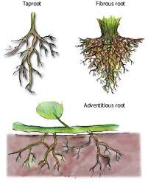

- IN LAB NOTEBOOK - Record Background Knowledge (minimum 2 sentences)

- READ Prompt Below & add to background knowledge IN LAB NOTEBOOK as needed. (minimum 2 sentences)
  - Despite its prominent root, the carrot has a very short, inconspicuous stem. You can see little of the carrot shoot system except the leaves that project from the tiny stem. Let's consider the large root and small stems we find on carrots in the grocery store in terms of the changes that occur in the life of a carrot plant. When carrots are grown from seed, the seedlings form both root and shoot systems as we would expect. The leaves of the shoot system grow quickly and use sunlight to make sugars through the process of photosynthesis. Much of this sugar is transported to the root, where it is stored. The accumulation of sugar in the root causes it to expand greatly, forming the tap root we find in grocery stores. Carrots in natural environments rather than gardens live for more than one year. At the end of their first year of growth, the leaves die and the tiny stem becomes dormant. Next year, in the spring, the sugars in the root are moved upward into the stem, which begins to grow. The stem extends upward and, ultimately, forms flowers and fruits. Flowering and fruiting often requires tremendous energy, and carrots store sugars in their roots during the first year of growth to make them readily available to be broken-down for energy when the flowers and fruits expand during the second year. Carrot stem In our gardens, we harvest carrots as a crop after their first year of growth in order to obtain the storage roots that are filled with nutrients. If left in the ground until the second year of growth, we would find shriveled roots from which all the nutrients had been extracted. Carrots show how parts of both the root and shoot system can modified. They have a large tap root that functions as a storage structure and a highly reduced stem that consists of little more than photosynthetic leaves, at least during their first year of growth. Carrots also provide an example of a strategy that plants have for resource storage and use. Carrots are biennials (each lives for two years) that make sugars and store them during their first year of growth and then use them during the second year for reproduction. Alternative strategies are used by other plants.

- Procedure. Read the procedure below, then re-read the procedure and DRAW (rather than writing it out) the steps to the procedure in your LAB NOTEBOOK PROCEDURE AREA.
  - Examine the whole carrot including its stems and leaves. Record your observations in individual sentences. Take note to how and where the stem(s) attach to the carrot root. What internal parts do you expect to be located in this region? Cut off a couple of stems at an angle. Record what you see.

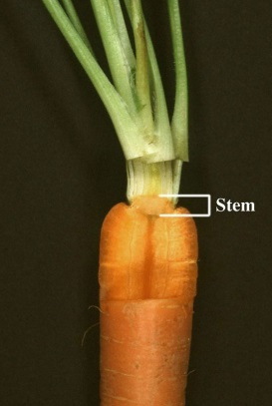
  - Now, very carefully, cut off the leaf stalks leaving the carrot stem attached to the root (if any). Examine the stem at the area where it meets with the root. Discuss what you see with another student. Next, very carefully, cut down lengthwise through the middle of the stem and into the carrot root a distance of about 2-3 cm. Then cut out this portion of the carrot so it roughly looks like the carrot in the photo to the right, only without the leaf stalks. Write down the tissue types you see from the outside toward the middle of the root starting with the epidermis.

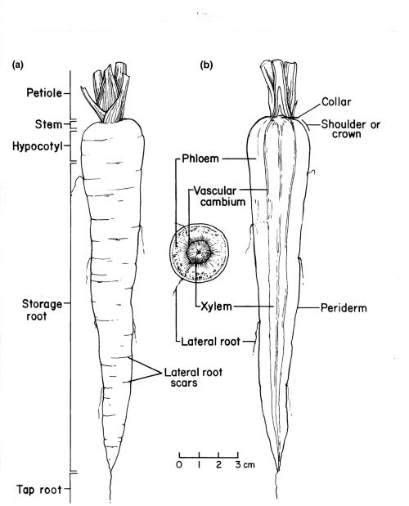
  - Next slice off that remaining portion so you have a cross section view. You now should have a carrot without its leaf stalks, stem, and 2-3 mm of the root. Set the top half portion you just cut off aside, you won’t need it. Then, make a simple drawing of the cross-section and label its various internal parts, highlight those you can SEE.

  - Draw a side view of the carrot and label its various external parts, highlight those you can SEE.

- Reflection: Answer the questions below in your LAB NOTEBOOK
The outside layer of the root is the epidermis. Root hairs grow from the epidermis (or periderm) a source of protection for the root. The secondary roots arise from the meristematic layer between the xylem and phloem layers called the cambium.
- What is the function of the root hairs?
- What is the name and function of the outer ring of cells of the root?
- What is the green portion at the top end of the carrot
- Why are taproots used as food more often than fibrous roots?
- When transplanting plants, why is it so important to move a lot of soil with it instead of just the main root itself?
- If you were to place a carrot in food coloring for 24 hours to allow transpiration to occur. What tissues of the root would have the most food coloring in it? Why?

