Name__________________________

Final – Large Animal Science – Calf Necropsy

Pre-Lab Questions - INDIVIDUAL:
- What is a necropsy?

- Why are necropsy’s performed (3-5 reasons)?

- Our calf has been frozen because due to great biosecurity, cow care and herd health, the farm does not often get calves that are still born or do not live. If we were veterinarians what would be the ample time to perform a necropsy? Why?

- What biosecurity techniques should be taken into account when performing a necropsy? Be detailed as to why each is needed.(3-5 precautions minimum)

Lab Supplies Needed:
Proper student clothing for labs (jackets, long pants, closed toe shoes/boots)
Gloves
Dissection kits and pruning sheers (or rib cutters)
Safety goggles
Ziploc bags (resealable)
Syringe
Permanent markers
Disinfectants
Optional – aprons, knife and sharpening set,

Prior to Cutting – External Analysis
- Write a written record of the animal (age, sex, species, breed, any signs of death, illness, known history/information, etc.)

- Check the eye, nose, mouth, rectum, and/or vulva for any blood/discharge. Note observations below. Note any issues with the integumentary system you see, be sure to note how a healthy integumentary system would appear.

- Note how/where the animal died, if other animals show illness/affected signs, or any other findings you may need to tell your vet. It may be useful to take photos now to reference later.

(Some producers may use a checklist similar to this to organize their data)
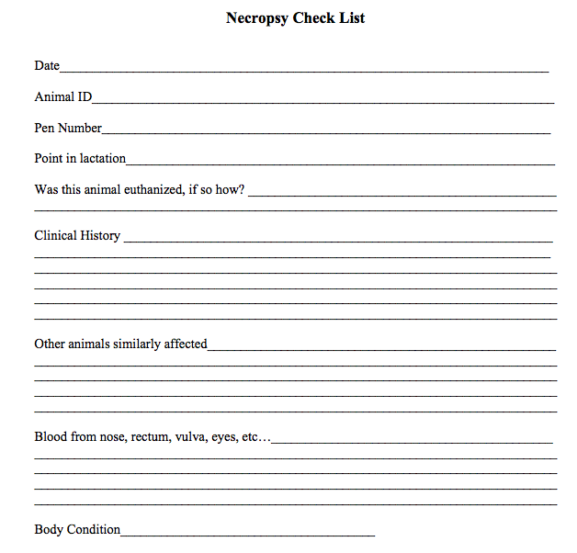
Field Necropsy – Steps

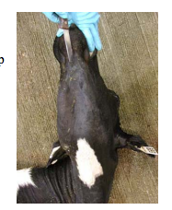
- Place animal on its sagittal plane so it’s right side is downward and head is facing up and to the right. This places the rumen downward making abdominal organs easier to see.
- Examine the external plant feet of the animal and verbally note any lesions, swelling or broken bones.
- Examine the external palm feet of the animal and verbally note any lesions, swelling or broken bones.
- Hold the neck/cranial region of the calf back to expose the neck.
- Make the first incision under the lower jaw of the animal. Place the tip of your scalpel/knife under the skin then make a smooth cut along the neck. (Photo top right)
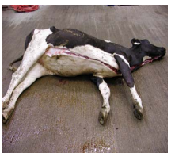
- Continue the skin incision between the dermal and muscle layers between the front limbs and above the external genitalia. (Photo middle right)
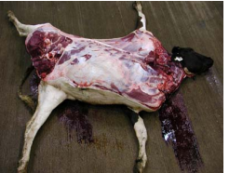
- USE CAUTION AS MULTIPLE PEOPLE ARE CUTTING AT ONCE – move in directions AWAY from each other. Using your knife/scalpel free the skin from the body wall of the animal starting at mid incision made and working toward the leg/spine as far as you can. You will need to cut through connective tissues between the hide and muscles. Try not to make holes in the hide is possible, the hide is the only part of the animal that could be salvaged after necropsy. (Photo lower right)
- Cut between the muscles of the forelimb shoulder and body wall by cutting the clear to white connective tissues between the muscles. Lift up on the forelimb and cut away the tissue you see while pulling on the limb. This will allow the leg to be at a right angle in comparison to the body. (Photo lower right)
- Repeat step eight but with the hind limb through the muscle toward the hip joint. There is a small ligament connecting the ball and socket of the hip joint. Cut through this ligament. (Photo lower right)
- At this time if we were necropsying a cow/heifer rather than a calf we would examine the mammary glands cutting through each teat in a ventral and linear fashion to examine mammary tissue and take tissue samples.
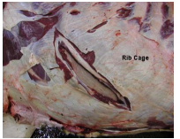
- Make an incision in the abdomen just behind the ribs. Start cutting very shallowly to avoid penetrating the underlying stomach/intestines. As shown in photo below.

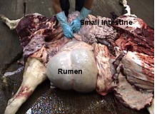
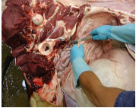
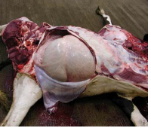
- Continue cut very shallowly along the ribs to create an abdominal flap. This flap will allow us to contain the organs in the carcass between removal and sampling. The greater thick tissue covering organs is called the greater omentum and hold the abdominal organs. (Below – LEFT)

- With one hand grab the back of the greater omentum near the hip joint like a sling and cut its thick wall of connective tissue away from the calf so you can observe all organs. (Above – CENTER)
- Work as a team to observe the abdominal cavity for each digestive tract organ we discussed. Note any size or color obscurities from what we discussed. Note your findings on the DIGESTIVE SYSTEM flip chart. Work as a team to LABEL each part of the digestive tract you can see & its function. Keep in mind the age of the animal and how that will affect the digestive tract. (Above – RIGHT) You may remove parts and work on a new table.
- The diaphragm lies under the last rib separating the abdominal and chest cavity. With a knife/scalpel puncture the diaphragm. Listen to hear if you can hear air move into chest cavity. After death there should continue to be negative pressure upon the chest cavity and lungs unless there is lung trauma or lack of lung development.
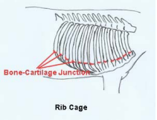
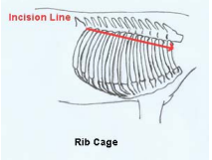
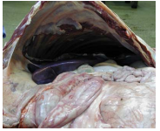
- Cut the entire right side of the diaphragm away from rib cage to allow for first look into chest cavity. (Bottom - LEFT)

- Cut the muscles covering rib cage along the top of the rib cage, near where ribs meet the spine. (Above – CENTER)
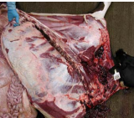
- Using force and pruning shears cut the ribs along the incision you just created. 13 ribs will need to be cut. (Above – RIGHT) This will be easier if you lift up on ribs to expose connective tissue to cut away then push down on ribs to fracture them at the junction between bone and cartilage (you will need to use force!) (Above –RIGHT and below)

- Work as a team to observe the respiratory cavity for each part of the respiratory system we discussed. Note any size or color obscurities from what we discussed. You may need to open the lungs to determine if the smooth muscling inside of them is fully developed, prior to freezing the calf’s lungs should be pink and spongy to the touch. Large amounts of blood, pus or a “popping” sound when touching are signs of respiratory failure. Note that after death blood pools downward so lungs should be darker toward lower muscles/cavities. Note your findings on the RESPIRATORY SYSTEM flip chart. Work as a team to LABEL each part of the respiratory system you can see and it’s function. You may remove parts.
- You may need to expand the cut down the neck to expose the jaw bone, esophagus and trachea. Cut between the jawbone on either side of where the tongue lays. Reach in and pull out the tongue. (Photos below)
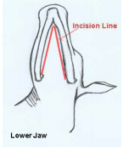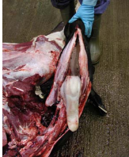
- Cut soft tissue of upper mouth while pulling on the tongue. You will see small hyoid bones on either side of the tongue which suspend the larynx and tongue. Use a small pruning shears to cut these bones and allow the tongue, trachea and esophagus to be removed up to the point of the lung. You may need to cut tendons and ligaments along the way. Cut open larynx and look for lesions, size and color discolorations.
- Continue to work as a team to observe the respiratory cavity for each part of the respiratory system we discussed. Note any size or color obscurities from what we discussed. Note your findings on the RESPIRATORY SYSTEM flip chart. Work as a team to LABEL each part of the respiratory system you can see and it’s function.
- Examine the thin sac surrounding the heart. Cut open the sac and make note of any lesions, adhesions, or a surplus of fluid. Large amounts of blood, fluid or pus are a sign of cardiac failure. (Photo bottom –LEFT)
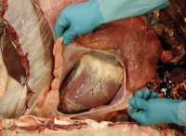
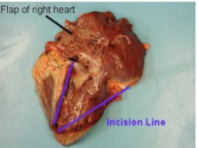

- Cut away the heart from the carcass to fully examine. You will need to carefully cut away from abdomen and lungs.
- Find the vena cava the major vessel that enters the heart from the abdomen and cut it lengthwise with scissors then continue on into the heart. Create an incision to examine the heart including each artery and ventricle (Photo above – RIGHT). Be sure to look at the values on the right of the heart to ensure it opens to properly allow for circulation. Prior to freezing the valves are smooth and shiny. On the left side of the heart you should see twice as thick walls with clotted blood that looks almost like a jelly. If you see any attached clots you know that could kill the calf and prevent circulation.
- Work as a team to observe the CIRCULATORY cavity for each part of the circulatory system we discussed. Note any size or color obscurities from what we discussed. Note your findings on the CIRCULATORY SYSTEM flip chart. Work as a team to LABEL each PART of the respiratory system you can see and it’s FUNCTION.
- Work with the digestive group to locate and find the kidneys. The left kidney should be where all the intestines meet, just above the rumen, covered by fat. (Photo below – RIGHT). Cut through the fat to expose the kidney. The right kidney is in a fat layer next to the liver close to the spine (Photo below – LEFT) . Pull away the fat then wrap your hand around the kidney and pull it out towards the tail cutting away ligaments as needed.
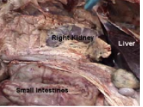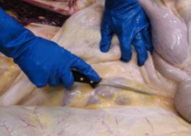
- Cut the kidney open length wise and examine inner tissues. Look for any dark coloration, pitting, stoning, or pus as a sign of kidney failure. Note
- Open the pelvis to expose the urinary bladder. If it is possible use a syringe and take a urine sample. Cut open the bladder to examine inner muscling and look for any strong smell, pitting, solids or blockage.
- Work as a team to observe the URINARY cavity for the kidneys and bladder Note any abnormalities and findings on URINARY FLIP CHART. Work as a team to LABEL each PART of the urinary system you can see and its FUNCTION.
- Work as a team to label examples of the three types to MUSCLES found on the animal. Note any abnormalities you see in muscle function/color on the MUSCLE SYSTEM flip chart.
- Work as a team to label examples of the four types to BONES found on the animal. Note any abnormalities you see in skeletal/bone function/color or any broken bones on the SKELETAL SYSTEM flip chart.

