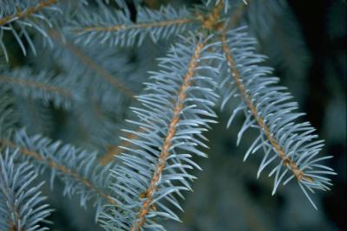
Name of Tree:
Type of Tree:
Needle Arrangement:
Use:

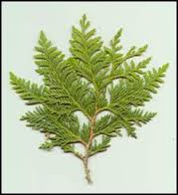
Name of Tree:
Type of Tree:
Needle Arrangement:
Use:

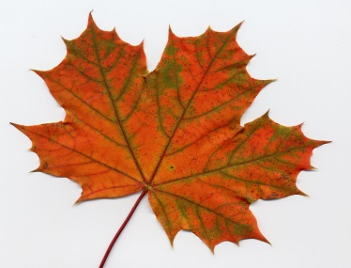
Name of Tree:
Type of Tree:
Leaf Arrangement/Desc.:
Use:

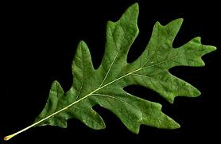
Name of Tree:
Type of Tree:
Leaf Arrangement/Desc.:
Use:

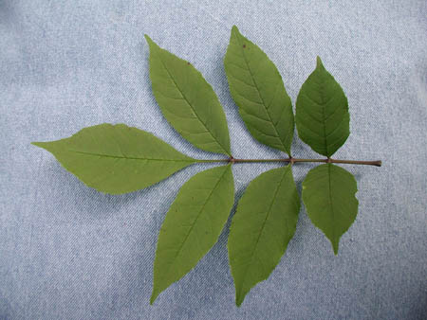
Name of Tree:
Type of Tree:
Leaf Arrangement/Desc.:
Use:
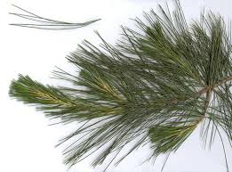
Name of Tree:
Type of Tree:
Needle Arrangement:
Use:

