NAME_____________________________

Injections Lab/Practice

Your patient is fragile and needs extra special care, as would all your patients. Be show GREAT RESPECT in this and all labs as they are a privilege to help learning not a right. This lab packet is due MONDAY.

Review of Injection Sites:
Label each of the following injection sites: Oral, Nasal, SubQ(SC), IM, IM, IV
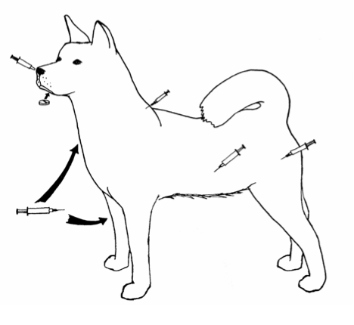

Review of Injection and Safety:
Match the site to its description:
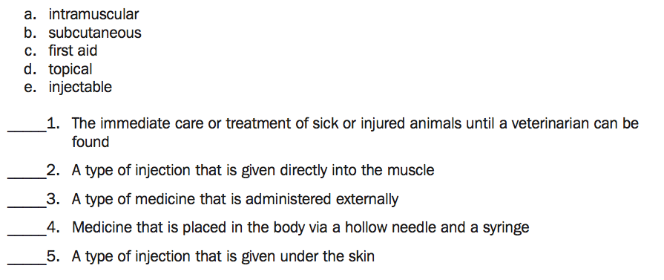

Lab Activity

BANANA
Intramuscular Injection
- Properly load 1 cc of BLUE medication into the syringe provided
- Prepare the injection site of your patient number 1
- Carefully inject the medication into the proper site using the techniques we discussed in class (pay close attention to the angle of your needle)
Subcutaneous Injection
- Properly load 1 cc of RED medication into the syringe provided
- Prepare the NEW injection site in patient number 1
- Carefully inject the medication into the proper site

*Unpeel your patient with Mrs. Propson and/or a peer and check your injections. If you performed this correctly the blue medication should be absorbed into the actual banana while the red medication should not be – it should be liquid and dripping out as it was under the skin layer not into the muscle. Continue practicing until you master this.

ORANGE
Intraveinous Injection
- Properly load 1 cc of BLUE medication into the syringe provided
- Prepare the injection site of your patient number 2
- Carefully inject the medication into the proper site using the techniques we discussed in class (pay close attention to the angle of your needle)
Intradermal Injection
- Properly load 1 cc of RED medication into the syringe provided
- Prepare the NEW injection site in patient number 2
- Carefully inject the medication into the proper site

*Unpeel your patient with Mrs. Propson and/or a peer and check your injections. If you performed this correctly the blue medication should be absorbed into the actual orange and you should see it moving through the cells of the orange while the red medication should not being absorbed into the cuticle or white of the orange. Continue practicing until you master this.

REFLECT (with solid reasoning and evidence)
- Which patient was easier to treat? Why?

- Did you perform your injections correctly? How can you tell? If you took multiple practices to master something explain your progress. If you did not master, how would you change your technique in the future?

- If we wanted to practice epidural injections how could we do so?

- What is the benefit of intramuscular injections over subcutaneous?

- If we wanted to practice intramammary injections how could we do so?

Syringe Types:
Analyze the following photographs to review parts of the syringe and see types of syringes.

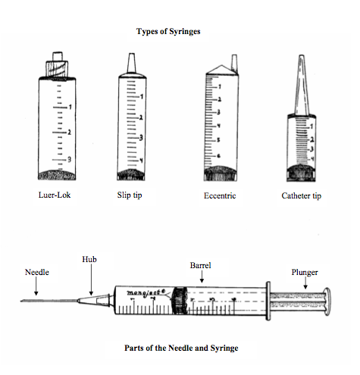

Review of Syringes:
For each syringe label WHAT TYPE it is and HOW MUCH medication is being administered.

Review os Syringes:
For each syringe label WHAT TYPE it is and HOW MUCH medication is being administered.
