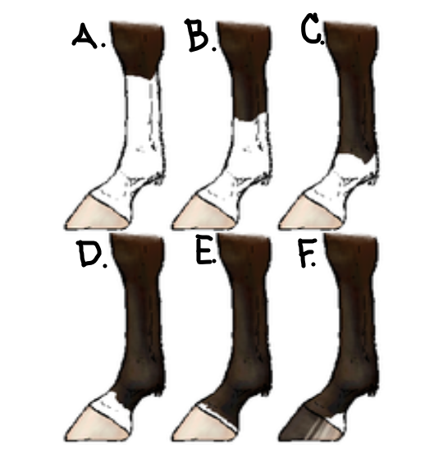
Name: ______________________________________
Label the horse leg markings below:
- _____________________________
- _____________________________
- _____________________________
- _____________________________
- _____________________________
- _____________________________
Label the Face Markings below:
- _____________________________
- _____________________________
- _____________________________
- _____________________________
- _____________________________
- _____________________________
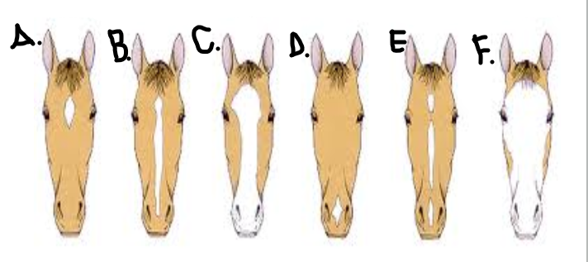
Word Bank:
Star Strip Blaze Bald Face Snip Irregular
Pastern Sock Heel Ankle Stocking Coronet
Equine Stereotypes/Vices
Type of Stereotype | Definition | Management Technique
Weaving
Cribbing
Bolting (Feed)
Coprophagy
Pica

