Name: ___________________________
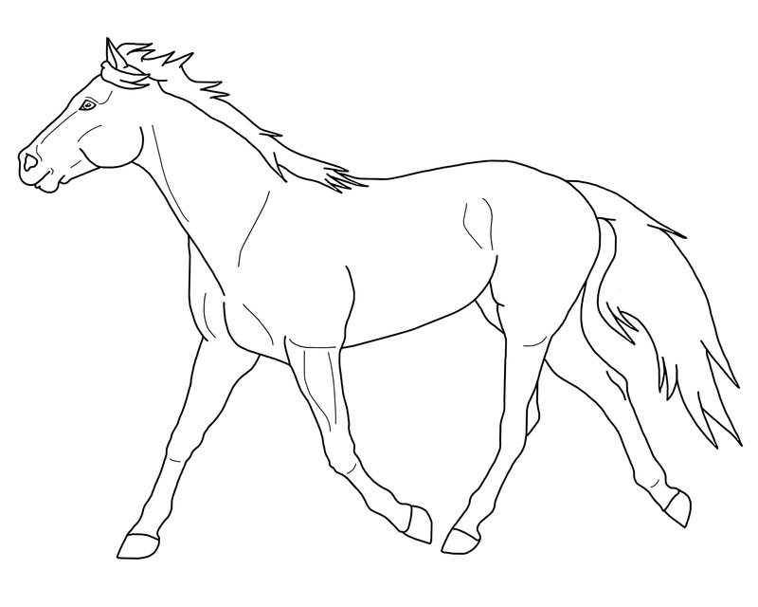
Palomino Red Dun

Buckskin Grullo

Sorrel Bay

Dapple Gray Flea-Bitten Gray

Mushroom Champagne

Red Silver Bay Roan

Rabicano White Horse with a Blood Mark

Rose Gray Brindle

Blanket Appaloosa Snowcap Appaloosa

Leopard Appaloosa Snowflake Appaloosa

