Punnett Squares – Agriscience
- Define genetics in your own words:
- Define allele in your own words:
- Define recessive in your own words:
- Define dominant in your own words:
- Define homozygous dominant in your own words:
- Define homozygous recessive in your own words:
- Define heterozygous in your own words:
- Define genotype in your own words:
- Define phenotype in your own words:
- What is Ms. Renier’s phenotype for eye color?
- What is Ms. Renier’s genotype for eye color?
- Define Punnett Square in your own words:
- In the space below, show the FIVE steps and the Punnett Squares you would use to determine the genotypes and phenotypes of the Octopus family shown here.
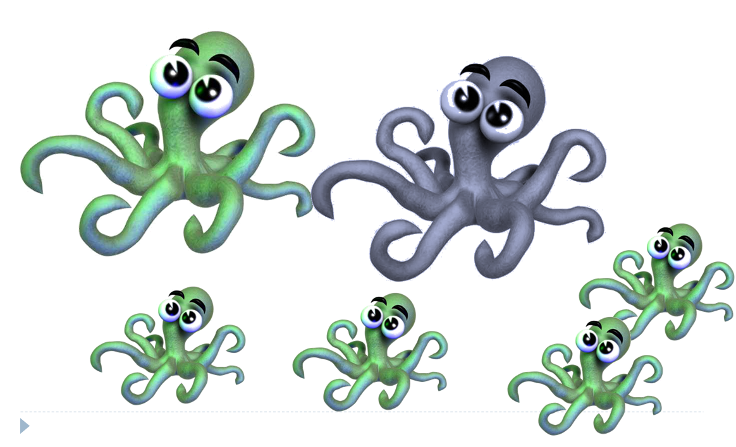
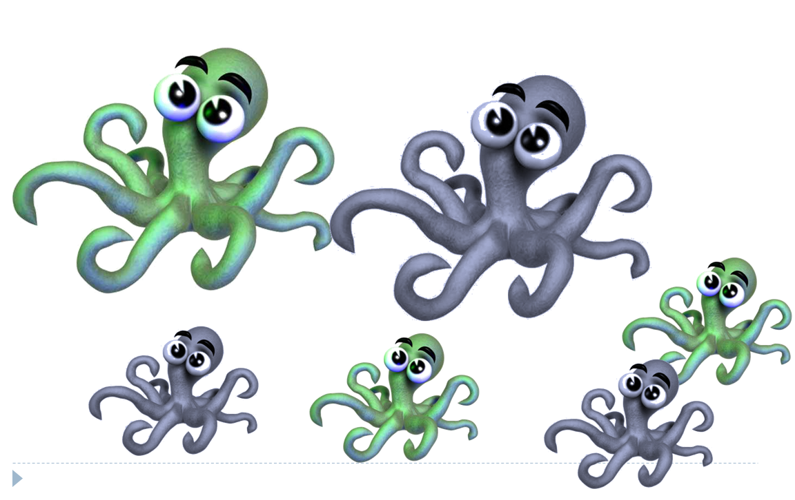
- In the space below, show the FIVE steps and the Punnett Squares you would use to determine the genotypes phenotypes of the Octopus family shown here.
- Write the six possible genotype combinations below:

- Complete the six possible genotype combinations in the Punnet squares below:

- What Questions do you have on this topic?

