Name_________________________________________________ Date__________

Reading a Fertilizer Label Activity

In the boxes below please provide the following information for each of the four fertilizer labels found around the classroom: Name of manufacturer, Brand and grade of fertilizer, Use, Net Weight, NPK percentage, One Secondary or Micronutrient and %.
1. Name of manufacturer:  Brand and grade of fertilizer:  Use:  Net Weight:  NPK percentage:  One Secondary or Micronutrient and %: | 2. Name of manufacturer:  Brand and grade of fertilizer:  Use:  Net Weight:  NPK percentage:  One Secondary or Micronutrient and %:
3. Name of manufacturer:  Brand and grade of fertilizer:  Use:  Net Weight:  NPK percentage:  One Secondary or Micronutrient and %: | 4. Name of manufacturer:  Brand and grade of fertilizer:  Use:  Net Weight:  NPK percentage:  One Secondary or Micronutrient and %:

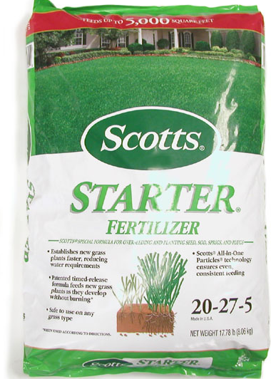
Fertilizer Bag #1
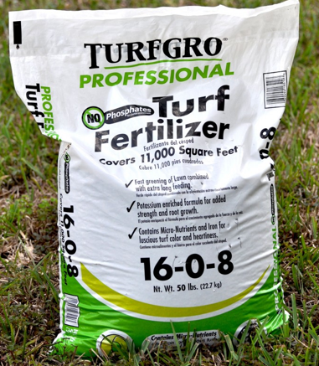
Fertilizer Bag #2
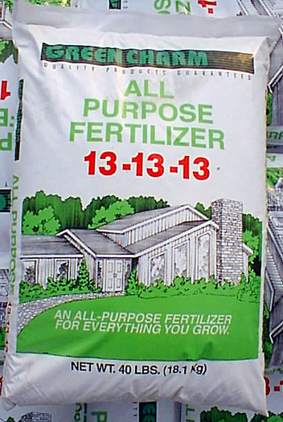
Fertilizer Bag #3
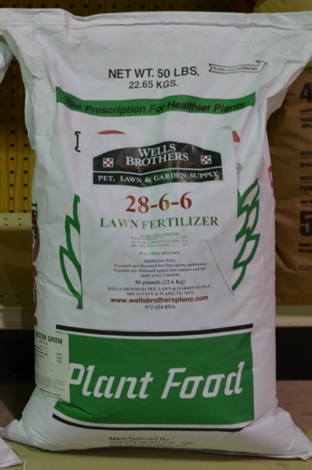
Fertilizer Bag #4

