SAE Project

- Choose a Supervised Agricultural Experience and approve your idea with Mrs. Propson
- LOG IN to www.theaet.com to add your experience
  - Hit STUDENT on the right hand side to login. Your Chapter is WI0159. Your username is your Mishicot user name (ex:19grlu) and your password to start is mishicot (you can change this once you login but make sure you retain or write it down for future reference.
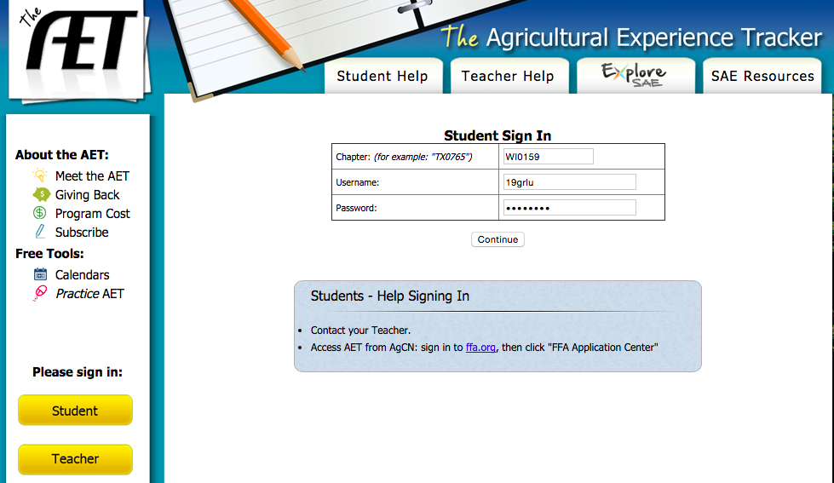

  - Once you login you will see your Dashboard, which should look like the photo below. Confirm that your name appears on the upper left.

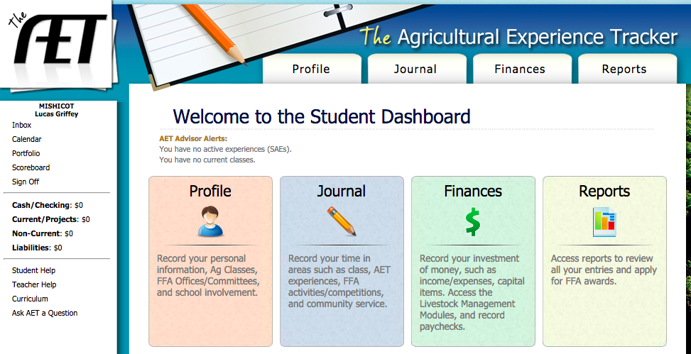

  - Use the PROFILE section to add your agriculture class you are currently in. This is also where you can change your password.
    - If you are a FFA member who will be applying for scholarships or awards you will also need to build a resume in this section. You can copy and paste from WisCareers or type directly into AET.

  - Use the JOURNAL section to add your SAE.
    - Go to EXPEREINCE MANAGER (SAE) and click ADD NEW on the top of the page. Add the name and description of your SAE. This is your first assignment. Ask peers and Mrs. Propson if you are unsure what type of SAE you have. If you are successful your page should look similar to the photo below.

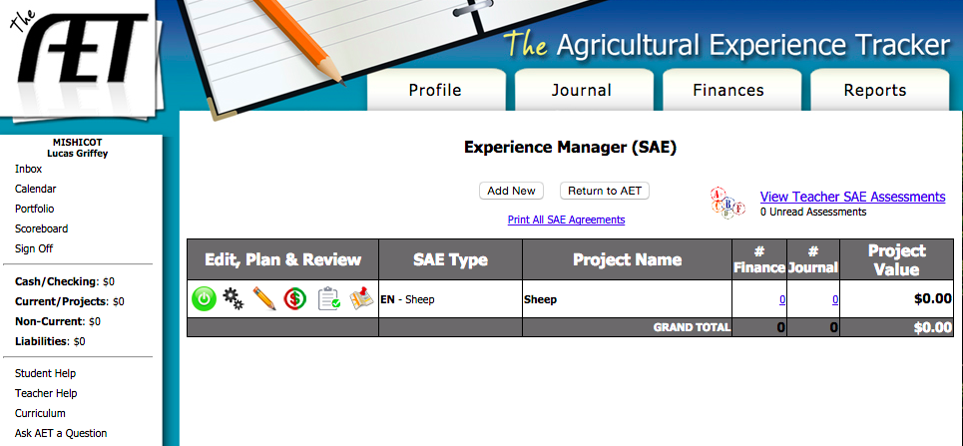

  - LOG your hours by clicking “TIME IN YOUR AET EXPERIENCES” on the JOURNAL dashboard.
    - Classroom – You need a minimum of SIX journal entries from SIX different days DURING THE TERM that add to a MINIMUM of TWENTY hours, PER TERM. (See Mrs. Propson if you will have difficultly completing this). See example log below.
    - FFA Members – It is in your best interest to be most competitive in your SAE area, scholarships and degrees to log ALL experiences throughout your FFA career.
      - For example –all hours showing and preparing sheep for fair over the summer as well as all hours working on a charter fishing boat over the summer and all hours assisting put on educational presentations at the elementary about agriculture during the school year.
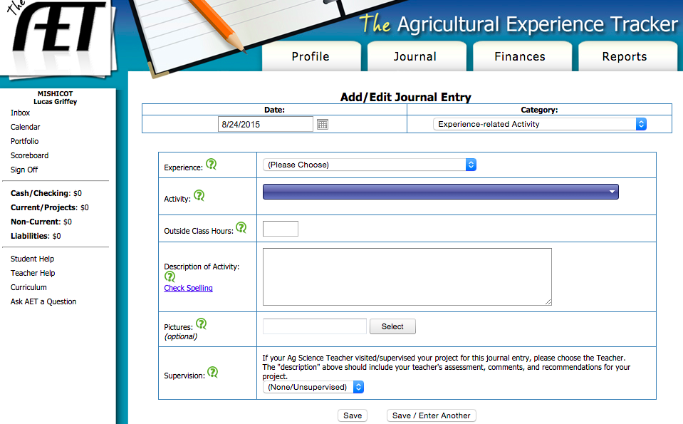

  - During the course of the class we will have SAE check in points that will be unannounced as well as announced. Make sure that you are working on your SAE throughout the class and can explain what you are doing, learning, and showcase your records on AET.

  - Final Project
    - SAE PRESENTATION – Create a 4-6 minute presentation about your SAE that includes the following:
      - ONE to SIX photos of YOU in/doing your SAE. You MUST be in the photo, action shots preferred.
      - Recap of what your SAE was, goals you had, progress you made.
      - Discussion of how this SAE will impact your future, career, college readiness, taught you lessons or formed networks, etc. (real life application)
      - Proper public speaking and professionalism throughout the presentation
      - Examples, videos, samples or other ways to both engage your audience and meet your four to six minute timeframe.

    - SAE REFLECTION – To be completed on Google docs and shared with Mrs. Propson. Each answer should be a minimum of 500 characters and maximum of 1500 characters.
      - Briefly explain your SAE.
      - Briefly explain your roles, responsibilities and/or management decisions in your SAE.
      - What is the single greatest challenge you faced in your SAE and how did you overcome it?
      - What are two accomplishments you have had in your SAE?
      - What are two ways that your experiences/opportunities in your SAE will impact your future?

    - SAE AUDIENCE GUIDE – As you watch other peers SAE presentations you will be completing a one page double-sided reflection analyzing their presentations and commenting on their experiences.

- GRADING – Your SAE is worth 10% of your grade, enough to drop or raise you one full letter grade. It is a 100-point project. See breakdown below:
  - 5 points – SAE Approval with Mrs. Propson
  - 5 points – AET Check In #1
  - 20 points – SAE Check In’s
  - 30 points – SAE Journals
  - 25 points – SAE Presentation
  - 10 points – SAE Reflection
  - 5 points – Audience Guide

- RESOURCES
  - www.mishicotffa.org
  - www.theaet.com
  - Community members, past students, FFA members, neighbors, parents, Mrs. Propson, peers
    - YOU will get the MOST out of this project if you align it with your INTEREST, HOBBIES, CAREER POTENTIAL or NETWORKING OPPORTUNTIEIS!

